**Identify Activity Centers for Travel Market Basket Definition**

This memo documents the method used to identify activity centers for travel market basket definition. Activity csenters of four trip purposes (HBW, HBS, HBR and HBO) are identified with the method proposed by Giulinao (1991): a center is defined as a continuous set of zones, each with density above some cutoff *D*, that together have at least *E* total employment and for which all the immediately adjacent zones outside the center have density below *D*.

Detailed steps are as follows:

1. Calculate TAZ level employment density for HBW and size terms[1] density for HBR, HBS, and HBO;
2. Identify TAZs with densities greater than cutoff *D*;
3. Group contiguous TAZs identified in step 2 into centers (with a Python script);
4. Calculate total employment or size terms for each center identified in step 3;
5. Eliminate centers with total employment or size terms below cutoff E from centers identified in step 3. The remaining are activity centers.

All employment data, including those by sector group, used in this process are from Longitudinal Employer-Household Dynamics (LEHD) aggregated to TAZ. Other data, such as households and park acres, are from travel demand model data provided by Metro.

The cutoff *D* and *E* should match the theoretical concept of centers, to be able to analyze commuting to centers, and to end with a manageable number suitable for statistical analysis. For HBW, I used a minimum total employment of 1000 and three employment density cutoffs: 2000 employees/km2, 2500 employees/km2, 3000 employees/km2. The density cutoff 2500 employees/km2 is close to Giulinao’s criterion: 10 employees per acre (2471.05 employees/km2). The histogram shows employment density distribution.

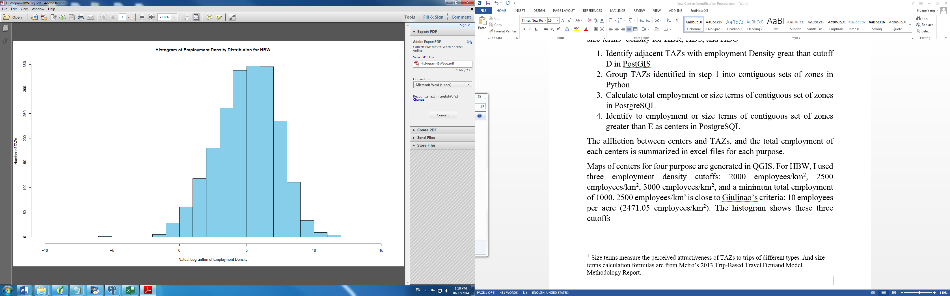

Fig. 1. Employment density distribution of HBW

For HBS, size terms is calculated as:

size terms = RetEmp +.008396*NonRet + .022126*Hhold

where

RetEmp = retail trade (NAICS 44, 45, 72)

NonRet = all employment other than retail

Hhold = Number of households in attraction TAZ

To identify appropriate criterion, I use six density cutoffs and one minimal total size terms of 1000. Six density cutoffs are percentiles of size terms density of all TAZs: 102 sizeterms/km2 (70%), 218 sizeterms/km2 (80%), 545 sizeterms/km2 (90%), 746 sizeterms/km2 (92.5%), 1060 sizeterms/km2 (95%), 1690 sizeterms/km2 (97.5%).  The histogram further shows the size terms density distribution.

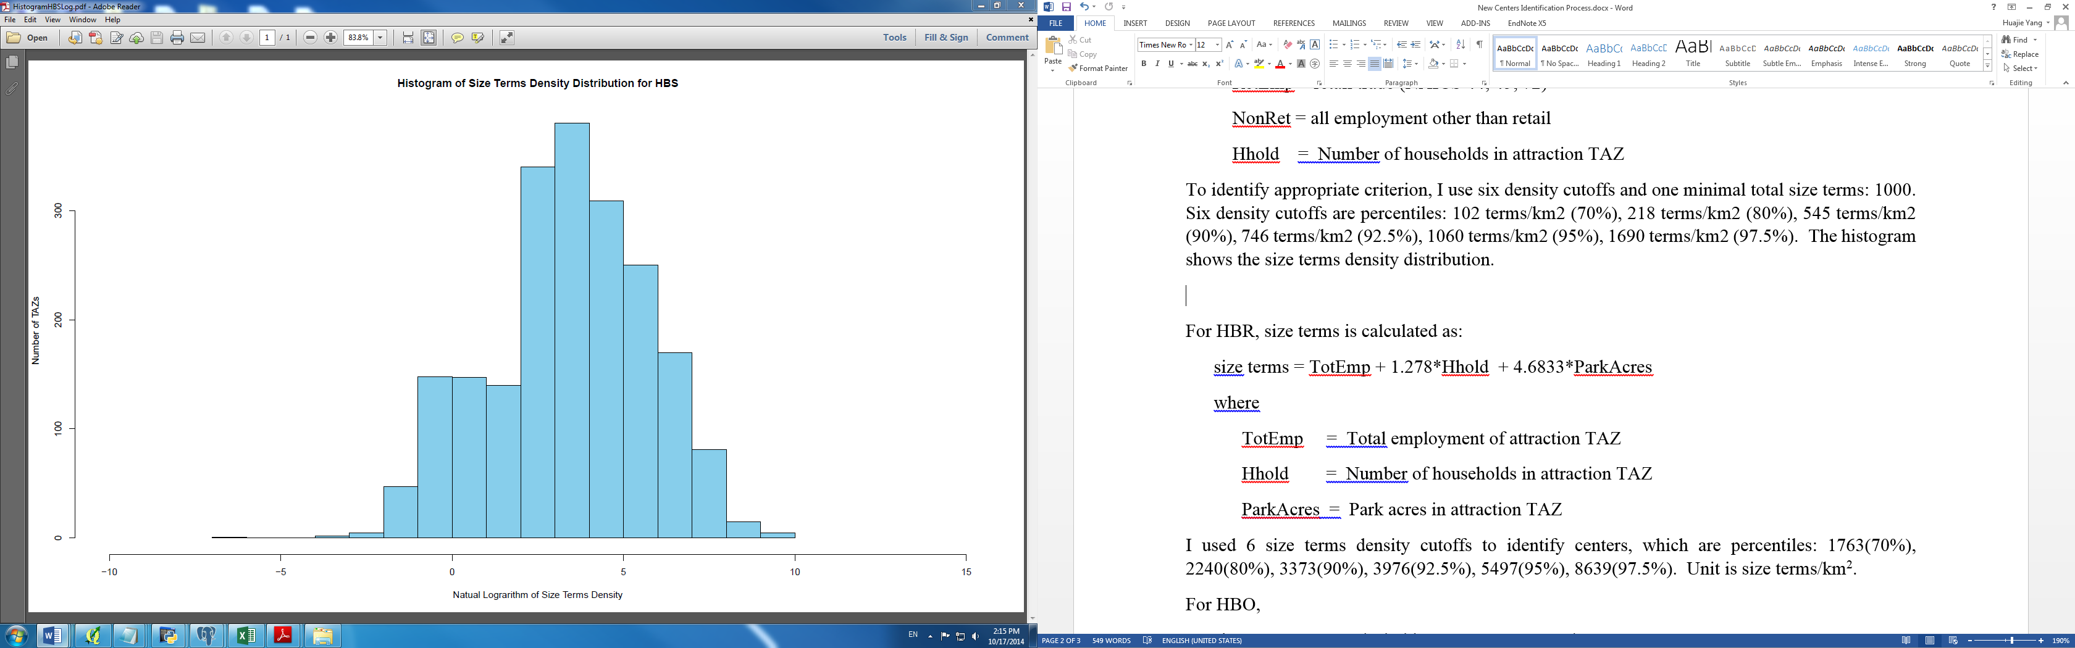

Fig. 2. Size terms density distribution of HBS

For HBR, size terms is calculated as:

size terms = TotEmp + 1.278*Hhold + 4.6833*ParkAcres

where

TotEmp = Total employment of attraction TAZ

Hhold = Number of households in attraction TAZ

ParkAcres = Park acres in attraction TAZ

To identify appropriate criterion, I use six density cutoffs and one minimal total size terms of 1000. Six density cutoffs are percentiles of size terms density of all TAZs: 1763 sizeterms/km2 (70%), 2240 sizeterms/km2 (80%), 3373 sizeterms/km2 (90%), 3976 sizeterms/km2 (92.5%), 5497 sizeterms/km2 (95%), 8639 sizeterms/km2 (97.5%).  The histogram further shows the size terms density distribution.

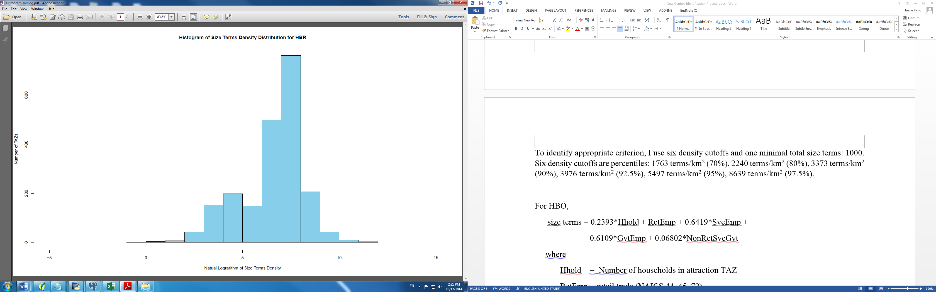

Fig. 3. Size terms density distribution of HBR

For HBO,

size terms = 0.2393*Hhold + RetEmp + 0.6419*SvcEmp +

0.6109*GvtEmp + 0.06802*NonRetSvcGvt

where

Hhold = Number of households in attraction TAZ

RetEmp = retail trade (NAICS 44, 45, 72)

SvcEmp = service (NAICS 51, 54, 56, 61, 62, 71, 81)

GvtEmp = government ownership service (NAICS 92)

NonRetSvcGvt = all employment other than retail, service, and government

To identify appropriate criterion, I use six density cutoffs and one minimal total size terms of 1000. Six density cutoffs are percentiles of size terms density of all TAZs: 495 sizeterms/km2 (70%), 765 sizeterms/km2 (80%), 1472 sizeterms/km2 (90%), 1873 sizeterms/km2 (92.5%), 2552 sizeterms/km2 (95%), 4254 sizeterms/km2 (97.5%). The histogram further shows the size terms density distribution.

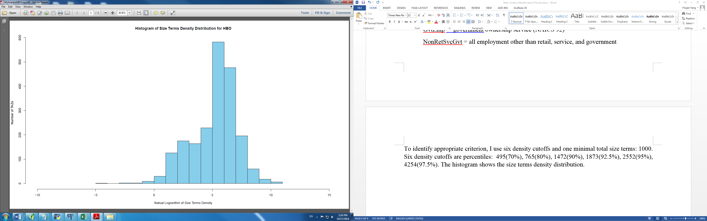

Fig. 4. Size terms density distribution of HBO

Maps of centers for the four purposes are generated in QGIS and included blew.

**References:**

Giuliano, G., & Small, K. A. (1991). Subcenters in the Los Angeles region.*Regional science and urban economics*, *21*(2), 163-182.

1. Size terms measure the perceived attractiveness of TAZs to trips of different types. And size terms calculation formulas are from Metro’s 2013 Trip-Based Travel Demand Model Methodology Report.